

# PROJECT REPORT

on

# BIBLIOREAD

*Submitted by*

ABHISHEK B KUMAR *(*33221802002*)*

ADARSH U (33221802004)

SIDHARTH JAYAN (33221802048)

VISHNU V NAIR (33221802055)

in partial fulfillment of the requirements for the award of

Bachelor of Computer Application degree of University of Kerala

***Department of Computer Science***

# COLLEGE OF APPLIED SCIENCE ADOOR 2020-2023



***CERTIFICATE***

Certified that this report titled *“BIBLIOREAD”* is a bonafide record of the project work done by

ABHISHEK B KUMAR *(*33221802002*)*

ADARSH U (33221802004)

SIDHARTH JAYAN (33221802048)

VISHNU V NAIR (33221802055)

Under our supervision and guidance, towards partial fulfillment of the requirements for the award of the Degree of BCA (Bachelor of Computer Applications) of

the University of Kerala

**Internal Guide Head of Department**

Asst. Prof. Femeena Fousiya S R Prof. Viji Balakrishnan

**Head of Institution External Guide**

Dr. Santhosh Babu K

# ACKNOWLEDGEMENT

Through this acknowledgement, we express our sincere gratitude to all the people who are associated with this project and have helped with it and made it a valuable experience. We take immense pleasure in thanking **Dr. Santhosh Babu K**, Principal of College of Applied Science Adoor for providing us with necessary facilities for doing this project. We express our deepest gratitude to the Head of the Department, **Prof. Viji Balakrishnan**, for their excellent guidance and constant encouragement towards successfully completing this project.

We express our heartfelt thanks to our internal guide **Asst. Prof. Femeena Fousiya S R**, for their valuable guidance and readiness to clear all our doubts and for guiding us towards the right path to make this project a successful one. We also extend our thanks to the various people who have shared their opinion and experience through which we received information, crucial for our report.

Finally, yet important, we would like to express our heartfelt thanks to our beloved parents for their blessings, our friends/classmates for their help and wishes for the successful completion of this project.

ABHISHEK B KUMAR

ADARSH U

SIDHARTH JAYAN

VISHNU V NAIR

# ABSTRACT

Books are infinite source of knowledge. Book reading gives us many knowledge about the world and about our surroundings .Everyone likes to read books but their categories are different some like historical book and some like story ,some other like entertaining and so on. People used book for acquaring knowledge and for spending time .But the major problem faced by the book lovers and book readers are lack of availability of book in our library and market.some book readers like to read books online and hear audio books.But the availability of these book are very rare.so we have to decide solve the problem faced by the bibliophiles by developing a webportal by connecting all book publishers by providing all books hard copy,softcopy and audiobook avaliability our webportal biblioread provide the three type of copies all all books.Any user can join the webportal by creating an account and register using their details.mainly three features are added to the webportal.we can search for a book in webportal show the book hardcopy ,softcopy and audiobook.we can buy hardcopy as like store,we will send it to your address and you can download softcopy of the book through online and we will send it to through the email.And also you can hear audiobook by taking monthly or weekly subscripition. You can Add feedback ,Post rating and reviews about the book

# TABLE OF CONTENTS

ACKNOWLEDGEMENT i

ABSTRACT ii

TABLE OF CONTENTS iii

LIST OF FIGURES v

LIST OF TABLES vi

LIST OF ABBREVATIONS vii

1. INTRODUCTION 1
   1. PROJECT OVERVIEW 2
   2. OBJECTIVES 2
2. SYSTEM ANALYSIS 3
   1. INTRODUCTION 4
   2. EXISTING SYSTEM 4
   3. PROPOSED SYSTEM 5
   4. FEASIBILITY STUDY 6
3. SYSTEM ENVIRONMENT 8
   1. INTRODUCTION 9
   2. SYSTEM REQUIREMENTS 9
   3. TECHNOLOGIES USED 10
      1. PROGRAMMING LANGAUGES 10
4. SYSTEM DESIGN 14
   1. INTRODUCTION 15
   2. PROCESS DESIGN 15
   3. USE CASE DIAGRAM 20
   4. DATA FLOW DIAGRAM 16
   5. SYSTEM DATA DESIGN 21
   6. USER INTERFACE DESIGN 26
5. CODING 30
   1. INTRODUCTION 31
   2. CODING SNIPPETS 31
6. SYSTEM TESTING 35
   1. INTRODUCTION 36
   2. WEBSITE 36
7. SYSTEM IMPLEMENTATION 42
   1. INTRODUCTION 42
   2. WEBSITE 42
8. CONCLUSION 43
9. FUTURE ENHANCEMENT 45
10. BIBLIOGRAPHY 47

# LIST OF FIGURES

|  |  |  |
| --- | --- | --- |
| **Figure No.** | **Figure Caption** | **Page No.** |
| Fig. 4.4.1 | Elements of Data Flow Diagram (DFD) | 16 |
| Fig. 4.4.2 | Context level Data Flow Diagram | 17 |
| Fig. 4.4.3 | Level 1 Data Flow Diagram of Website- ADMIN | 18 |
| Fig. 4.4.4 | Level 1 Data Flow Diagram of Website - PUBLISHER | 19 |
| Fig. 4.4.5 | Level 1 Data Flow Diagram of Website - USER | 20 |
| Fig. 4.7.6 | Screenshot of Website’s home page | 26 |
| Fig. 4.7.7 | Screenshot of login page of user in website | 26 |
| Fig. 4.7.8 | Screenshot of admin login in website | 27 |
| Fig. 4.7.9 | Screenshot of publisherlogin in website | 27 |
| Fig. 4.7.10 | Screenshot of user signup in website | 28 |
| Fig. 4.7.11 | Screenshot of publisher signup in website | 28 |
| Fig. 4.7.12 | Screenshot of details of book in website | 29 |

# LIST OF TABLES

|  |  |  |
| --- | --- | --- |
| **Table No.** | **Table Caption** | **Page No.** |
| Table 4.6.1 | Structure of admin login | 21 |
| Table 4.6.2 | Structure of User login | 22 |
| Table 4.6.3 | Structure of Publisher login | 22 |
| Table 4.6.4 | Structure of Publisher signup | 23 |
| Table 4.6.5 | Structure of feedback | 24 |
| Table 4.6.6 | Structure of User registration | 23 |

# LIST OF ABBREVATIONS

|  |  |  |
| --- | --- | --- |
| **S. No.** | **Abbrevation** | **Full Form** |
| 1 | Asst. Prof. | Assistant Professor |
| 2 | Prof. | Professor |
| 3 | HTML | HyperText Markup Langauge |
| 4 | CSS | Cascading Style Sheet |
| 5 | JS | JavaScript |
| 6 | PHP | PHP Hypertext Preprocessor |
| 7 | SQL | Structured Query Language |
| 8 | DFD | Data Flow Diagram |

# 1. INTRODUCTION

## PROJECT OVERVIEW

Welcome to the project documentation for "BiblioRead," an innovative online platform desfigned to cater to the diverse reading preferences of book enthusiasts. BiblioRead is a dynamic website that offers a comprehensive library of reading materials, including audiobooks, hard copies, and ebooks. This documentation will provide you with a comprehensive overview of the BiblioRead project, detailing its objectives, features, development process, and the technology stack employed to create this versatile reading platform. In an increasingly digital age, the way we consume literature and written content is rapidly evolving. BiblioRead was conceived as a response to the evolving needs of readers who seek convenient access to books, magazines, academic journals, and other written materials. Whether you prefer the tactile sensation of a physical book, the portability of an ebook or an audio book BiblioRead has been designed to accommodate your preferences. In an increasingly digital age, the way we consume literature and written content is rapidly evolving. BiblioRead was conceived as a response to the evolving needs of readers who seek convenient access to books, magazines, academic journals, and other written materials. Whether you prefer the tactile sensation of a physical book, the portability of an ebook or an audio book BiblioRead has been designed to accommodate your preferences.

## OBJECTIVES

* + 1. Diverse Content Repository: BiblioRead aims to curate a vast and varied collection of reading materials, spanning genres, subjects, and languages to cater to a wide audience.
    2. Accessibility: The project's primary objective is to make reading accessible to all, regardless of physical location, with options for audiobooks, hard copies, and ebooks..
    3. User-Friendly Interface: BiblioRead seeks to provide an intuitive and user-friendly interface that simplifies the browsing, selection, and acquisition of reading materials.
    4. Secure Transactions: Ensuring secure transactions for purchasing hard copies and ebooks is paramount, safeguarding user data and payment information.
    5. Community Engagement: BiblioRead fosters a vibrant reading community through user reviews, ratings, and recommendations, enhancing the reading experience for all.

# SYSTEM ANALYSIS

## INTRODUCTION

A system is simply a set of components to accomplish an objective. Developing a new system, investigating into the operation and making possible changes in the existing system are called System Analysis. Analysis comprises a detailed study of the various operations performed by a system and their relationships within and outside the system. It is the process of gathering and interpreting facts, diagnosing problems and improving the system using the information obtained.

The objectives of System Analysis include the following

* + - Identifying the user’s needs.
    - Performing economic and technical analysis.
    - Establishing cost and schedule constraints.

Here the system analyst should study a system with an eye on solving the problem using computers. It is an essential part for the development of a project by a system analyst. System analysis is for finding out what happens in the existing systems, deciding on what changes and new features are required and defining exactly what the proposed system must be. This process of system analysis is largely concerned with determining, developing and agreeing to the user’s requirements. It provides prime opportunities to communicate well with the user and conceive a joint understanding of what a system should be doing, together with a view of the relative importance of the system facilities using interactive techniques.

To analyze a system, one has to study the system's work in detail. The system analyst has to understand the functioning and concept of the system in detail, before designing the appropriate computer based system that will meet all the requirements.

## EXISTING SYSTEM

The web site is able to allow end users or requestors to sign up for an account. This requires a lot of hard work and time consumption to complete the task. This may include human errors. In the existing system, there is no sites which has the hardcopy ,softcopy and audiobook is available all in one website. there is only each site for these each purposes.it should be very difficult to find bibliophile to which one will choose. The existing system will not provide information about the book and demo videos. Hence make a site which accompanies three in one is better

## Disadvantages

* Need a large volume of storage area.
* Difficult to access Hardcopy ,Softcopy and audiobook together
* More man power required
* Difficult to know about the content
* Lack of demo videos about audiobooks\
* Three kind of books takes different site
* Searching of information was time consuming..

## PROPOSED SYSTEM

BiblioRead is a dynamic website that offers a comprehensive library of reading materials, including audiobooks, hard copies, and ebooks.. The web page will allow speeding up the acess of users to the books. The main objective of this application is to make it interactive and easy to use. This application is helpful in finding Hard copies ,soft copies and audiobooks together. The main motive of this project is to find the books in different format for a bibliophile very easily and time saving.

## Advantages

* Reduce time consumption
* Avoids unauthorized access on data.
* View ratings and reviews publically.
* Authorized publishers only can upload books.
* Provides three format of book in one website.
* Provides the demo videos and description along with the book.

## FEASIBILITY STUDY

A preliminary investigation examines project feasibility. Feasibility study is a small scale system analysis. It is necessary as it evaluates the feasibility of a project at the earliest possible time.

Types of feasibility study:

* + - Technical feasibility
    - Operational feasibility
    - Functional feasibility
    - Economical feasibility
    - Social feasibility

## Technical feasibility

It is the study of resource availability that may affect the ability to achieve an acceptable system. The system must be evaluated from the technical viewpoint first. The assessment of this feasibility must be based on an outline design of the system requirements in terms of input, output, program procedure, etc. Having identified the outline of the system, the investigation must go on to suggest the type of equipment, required method of developing the system, and the method of running the system. The outcome of the study was found to be positive.

## Operational feasibility

Operational feasibility is the measure of how well a proposed system solves the problems, and takes advantage of the opportunities identified during scope definition and how it satisfies the requirements identified in the requirements analysis phase of system development. The outcome of the study was satisfactory.

## Functional feasibility

Here we examine the functions of the system which may work properly when implemented. The proposed system has functions that can be implemented successfully. Hence the project was found to be functionally feasible.

## Economical feasibility

It is considered as the final stage of most systems, it includes a broad range of concerns that include cost benefit analysis. The proposed system was found to be economically feasible as its requirements did not require huge expenditure, the group also had the knowledge to undertake this task without any difficulty.

## Social feasibility

Social feasibility is a detailed study on how one interacts with others within a system or an organization. Social impact analysis is an exercise aimed at identifying and analyzing such impacts in order to understand the scale and reach of the project’s social impacts. This project has a great impact on the adoption of Linux on PCs by making software more accessible and easy to access and maintain.

# SYSTEM ENVIRONMENT

## INTRODUCTION

A system environment refers to the collection of hardware, software, and data that make up a computer system. This includes the physical components of a computer such as the CPU, memory, storage devices, and input/output devices, as well as the software applications and operating system that run on it. The system environment also includes the network connections and protocols used to communicate with other devices and systems. Understanding the system environment is crucial for troubleshooting, optimizing performance, and developing software applications that work effectively in a particular system environment.

## SYSTEM REQUIREMENTS

Requirements for Biblioread are a set of documented needs and expectations that define what the website must accomplish to satisfy its users .These requirements encompass both functional and non-functional aspects to ensure the website's success.

Functional Requirements:

Functional requirements for Biblioread outline the specific features and capabilities that the website must possess to serve its users effectively. These may include features like user registration, book search functionality, online checkout for hard copies, ebook downloads,listening audiobook and user reviews.

Non-functional Requirements:

Non-functional requirements for Biblioread address the performance, usability, security, and reliability aspects of the website. These requirements could include parameters such as page load times, data security protocols, responsive design for various devices, and compliance with accessibility standards.

Use Cases:

Use cases for Biblioread represent scenarios or interactions that users may have with the website. Each use case describes a specific user goal and the steps they take to achieve it on the platform. Examples of use cases for Biblioread could be "User searches for a book," "User purchases an ebook," or "User leaves a book review."

## TECHNOLOGIES USED

* + 1. **Programming languages**
       1. **PHP**

PHP (Hypertext Preprocessor) is a widely used open-source scripting language that is primarily designed for web development. It is a server-side scripting language, which means it is executed on the web server before the web page is sent to the client's browser. PHP is often embedded within HTML code to create dynamic web pages and web applications.

## Features in PHP

## Server-Side Scripting

## PHP is executed on the web server, allowing developers to create dynamic web pages by generating HTML content on the fly. This enables the creation of interactive and data-driven websites.

## Open Source

## PHP is open-source and freely available. This has contributed to its widespread adoption and the creation of a large and active community of developers.

## Cross-Platform Compatibility

## PHP can be used on various operating systems (Windows, Linux, macOS) and is compatible with most web servers (e.g., Apache, Nginx, IIS).

## Database Integration

## PHP can connect to various database systems, making it well-suited for building database-driven web applications. Popular database systems like MySQL, PostgreSQL, and SQLite are often used in conjunction with PHP.

## Extensible

## PHP is highly extensible, and developers can add custom functionality through extensions and libraries. There is a vast ecosystem of PHP libraries and frameworks available for different purposes, such as Laravel, Symfony, and WordPress.

## Embeddable

## PHP code can be embedded within HTML files using special tags, making it easy to mix dynamic and static content in web pages.

## Fast Execution

## PHP is known for its relatively fast execution, making it suitable for handling web requests efficiently.

## Community Support

## PHP has a large and active community of developers who contribute to its development and offer support through forums, documentation, and online resources.

## Security Features

## PHP includes built-in security features to help developers protect their applications against common web vulnerabilities, such as SQL injection and cross-site scripting (XSS).

.

## HTML

HTML, or Hypertext Markup Language, is a markup language used for creating web pages and applications. HTML provides the structure and content of a web page, defining headings, paragraphs, links, images, and other elements that make up the page. It is often assisted by technologies such as Cascading Style Sheets and scripting languages such as JavaScript. HTML is a cornerstone technology for web development and is essential for creating any kind of web page or application. HTML is easy to learn and understand, making it accessible to developers of all skill levels.

## CSS

CSS, or Cascading Style Sheets, is a style sheet language used to describe the presentation and styling of HTML documents. CSS provides the means to control the layout, typography, colors, and other visual aspects of a web page, allowing developers to create visually appealing and engaging websites. CSS is an essential component of web development, working in conjunction with HTML to create a seamless and visually appealing user experience.

## JavaScript

JavaScript is a popular programming language that is used to create interactive web applications and dynamic user interfaces. Developed by Netscape in 1995, JavaScript has become one of the most widely used programming languages in the world. JavaScript is a client-side scripting language, which means that it runs in the user's web browser and can be used to modify the content and behavior of a web page. JavaScript is an essential tool for web developers, enabling them to create engaging and interactive web applications that respond to user input and events. JavaScript is also used extensively in web development frameworks and libraries, such as React and Angular, which provide a range of pre-built components and tools for building complex web applications. The popularity of JavaScript has led to a large community of developers who contribute to its development, making it a powerful and versatile language that is constantly evolving to meet the needs of modern web development.

## MySQL

Relational database systems are the most important database systems used in the software industry today. One of the most outstanding systems is MySQL.

The important aspects of SQL Server are:

* + MySQL is easy to use.
  + Embedded database library.
  + Commit grouping, gathering multiple transactions from multiple connections together to increase the number of commits per second.

MySQL is a popular choice of database for use in web applications, and is a central component of the widely used [LAMP](https://en.wikipedia.org/wiki/LAMP_(software_bundle)) open source web application software stack (and other "[AMP](https://en.wikipedia.org/wiki/List_of_AMP_packages)" stacks). LAMP is an acronym for "[Linux](https://en.wikipedia.org/wiki/Linux), [Apache](https://en.wikipedia.org/wiki/Apache_HTTP_Server), MySQL, [Perl](https://en.wikipedia.org/wiki/Perl)/[PHP](https://en.wikipedia.org/wiki/PHP)/[Python](https://en.wikipedia.org/wiki/Python_(programming_language))." [Free-software](https://en.wikipedia.org/wiki/Free_software)-open source projects that require a full-featured database management system often use MySQL.

On all platforms except Windows, MySQL ships with no [GUI](https://en.wikipedia.org/wiki/Graphical_user_interface) tools to administer MySQL databases or manage data contained within the databases. Users may use the included [command line](https://en.wikipedia.org/wiki/Command_line) tools, or install [MySQL workbench](http://dev.mysql.com/downloads/workbench/) via a separate download. Many third-party GUI tools are also available.

# 4.SYSTEM DESIGN

## INTRODUCTION

System design is a crucial phase in the software development life cycle where a high-level conceptual design is created for the proposed system. It involves defining the architecture, components, modules, interfaces, and data for a system to satisfy specified requirements. The objective of system design is to translate the requirements gathered during the analysis phase into a detailed design that can be implemented by the developers. A well-designed system is essential for ensuring that the final product meets the user's expectations, is maintainable, scalable, and can be easily modified or updated in the future. A thorough system design is also important for estimating the development effort, cost, and resources required to build the system.

## PROCESS DESIGN Modules

* + 1. Website
       1. ADMINISTRATOR

Verify uploading of new e-books and audiobooks

List out new hardcopy booklist

Manage user and user rating reviews

Manage publishers and their book uploads

* + - 1. PUBLISHER

Upload audiobooks,e-books

Update Hard copy stock list

Verify users review and ratings

Verify payment status

* + - 1. USER

Registration

Payement

Post book reviews

Add rating to the audiobooks

## DATA FLOW DIAGRAM (DFD)

A data-flow diagram is a way of representing a flow of data through a process or a system (usually an information system). The DFD also provides information about the outputs and inputs of each entity and the process itself. A data-flow diagram has no control flow,  there are no decision rules and no loops.

For each data flow, at least one of the endpoints (source and / or destination) must exist in a process. The refined representation of a process can be done in another data-flow diagram, which subdivides this process into sub-processes. The data-flow diagram is a tool that is part of structured analysis and data modeling.

The basic elements of Data Flow Diagram are :

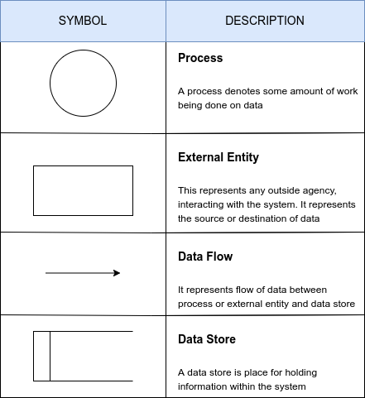

Fig 4.4.1 Elements of Data Flow Diagram (DFD)

## BIBLIOREAD

Context level

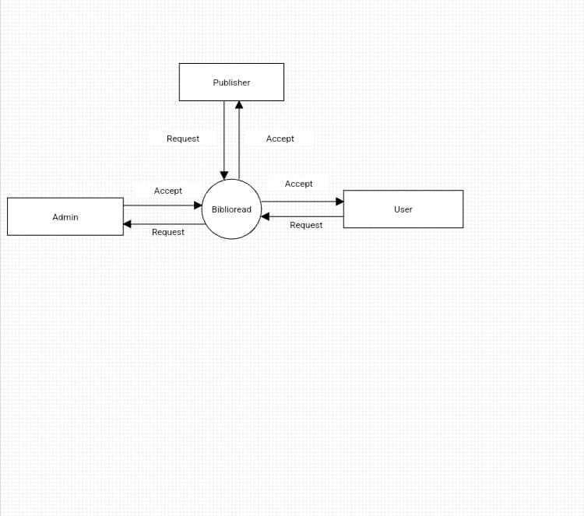

Fig 4.4.2 Context level Data Flow Diagram of BIBLIOREAD

Level 1

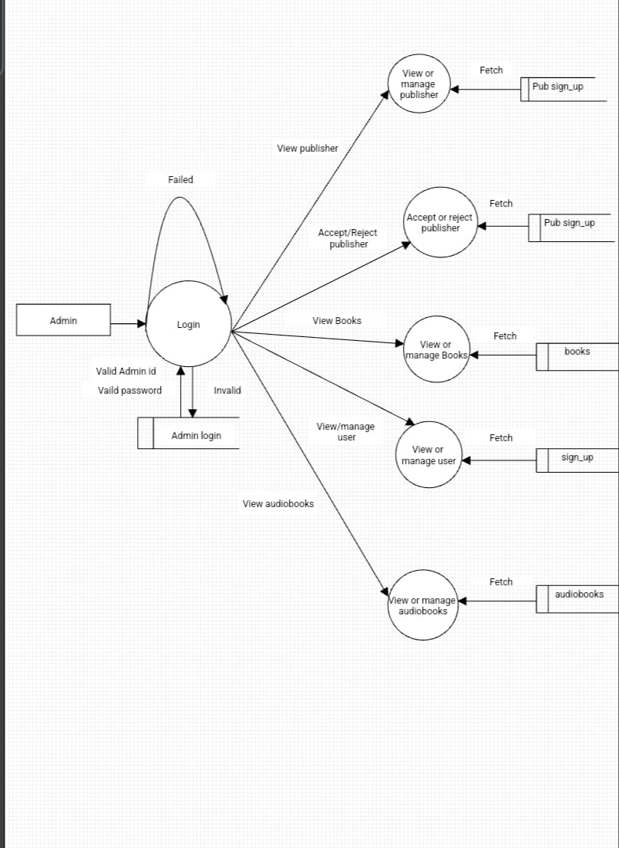

Fig 4.4.3 Level 1 1 Data Flow Diagram of Website - ADMIN

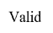 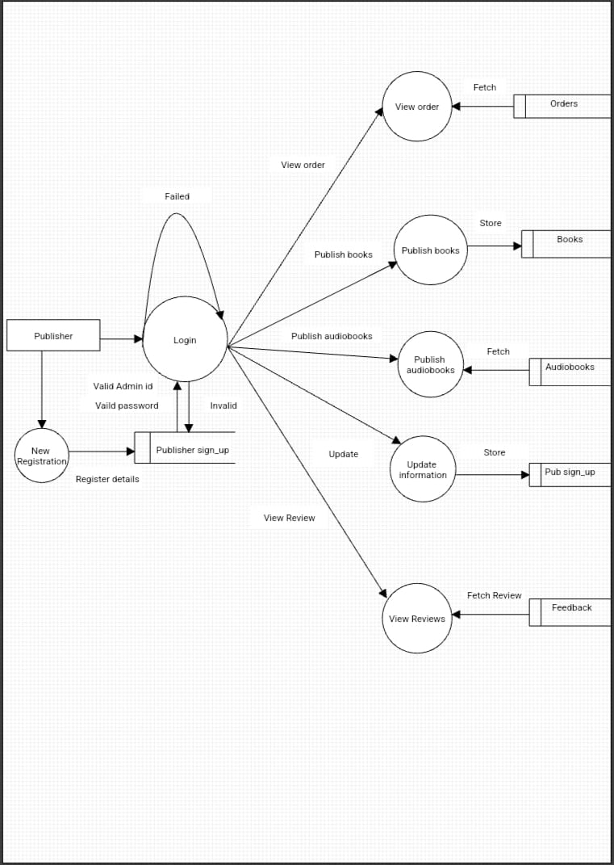

Fig 4.4.5 Level 1 Data Flow Diagram of Website - PUBLISHER

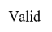 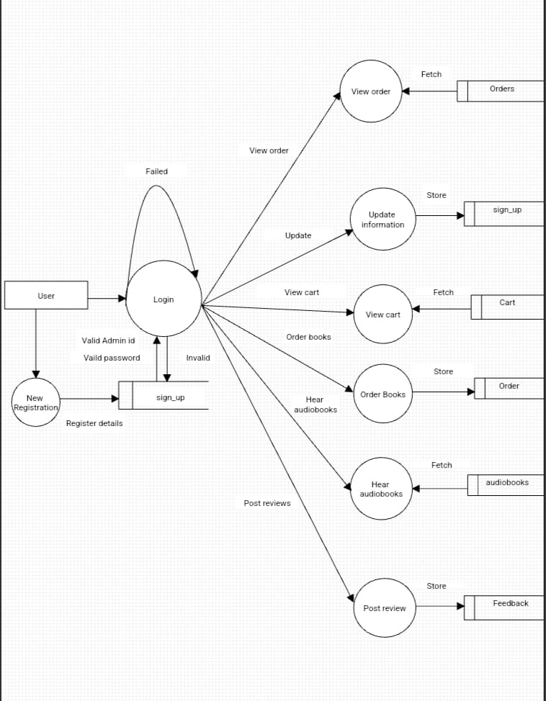

Fig 4.4.6 Level 2 Data Flow Diagram of Website – USER

## SYSTEM DATA DESIGN

System data design is an essential aspect of system development that involves the creation of a structured and organized data storage and retrieval system. The database and configuration design are critical components of the data design process, as they provide the foundation for storing and managing the system's data. The database design includes the creation of tables, relationships, and constraints to ensure that data is stored accurately and efficiently. Configuration design, on the other hand, involves defining the various settings and parameters that govern the behavior of the system. Together, these design elements enable the system to operate effectively and efficiently, ensuring that data is stored, retrieved, and utilized in a manner that supports the system's overall functionality.

## Website

* + 1. Table Name: adminlogin

Description: This table is used for details to store of admin to login

|  |  |  |  |
| --- | --- | --- | --- |
| Field name | Datatype | Constraints | Description |
| adminname | Varchar | Not null | Admin name |
| password | Varchar | Not null | Password of the admin |
| a_id | Int | Primary | Id of the admin |

* + 1. Table Name: login

Description: This table is used for details of users who logged in

|  |  |  |  |
| --- | --- | --- | --- |
| Field name | Datatype | Constraints | Descriptions |
| username | Varchar | Not null | Name of the user |
| password | Varchar | Not null | Password of the user |

1. Table Name: pub login

Description: This table is used for details of publishers who logged in

|  |  |  |  |
| --- | --- | --- | --- |
| Field name | Datatype | constraints | Descriptions |
| pubname | Varchar | Not null | Publisher name |
| password | Varchar | Not null | Password |

1. Table Name: pub_signup

Description: This table is used for register publisher

|  |  |  |  |
| --- | --- | --- | --- |
| Field name | Datatype | Constraints | Descriptions |
| id | int | Primary | Id of the publisher |
| **publishername** | Varchar | Not null | Name of publisher |
| **publicationname** | char | Not null | Name of the publication |
| **publicationadrs** | Varchar | Not null | Address of the publication |
| **phonenumber** | Varchar | Not null | Phone number |
| **email** | Varchar | Not null | Email of the publication |
| **doo** | date | Not null | Origin date of the publication |
| **document** | varchar | Not null | Id proof |
| **password** | Varchar | Not null | password |
| **approval_status** | enum('approved', 'rejected', 'pending') | Not null | approval status given by admin |

1. Table Name: signup

Description: This table is used for registered users

|  |  |  |  |
| --- | --- | --- | --- |
| Field name | Datatype | Constraints | Descriptions |
| u_id | int | primary | Id of the user |
| name | varchar | Not null | User name |
| email | varchar | Not null | User email |
| password | varchar | Not null | password |
| confirmpass | varchar | Not null | Confirmation of password |
| address | varchar | Not null | Address of the user |
| phonenumber | int | Not null | Phone number |
| country | char | Not null | Country of the user |

1. name: feedback

Description: This table is used for feedback details

|  |  |  |  |
| --- | --- | --- | --- |
| Field name | Datatype | Constraints | Descriptions |
| id | Int | Primary key | feedback id |
| rating | int | Not null | Number of rating |
| review | varchar | Not null | Review by user |

1. Table Name: audiobooks

Description: This table is used for publishing audiobooks

|  |  |  |  |
| --- | --- | --- | --- |
| Field name | Datatype | Constraints | Descriptions |
| id | int | Foreign key | audiobookid |
| publication_name | varchar | null | publication name |
| audio_tittle | varchar | Not null | tittle of the audiobook |
| audio_author | varchar | Not null | Author of the audiobook |
| audio_description | text | Not null | Description of the audiobook |
| audio_genre | varchar | null | Genre of the audiobook |
| audio_file_path | varchar | Not null | Path where the file is uploaded from |

1. Table Name: books

Description: This table is used for publishing book details

|  |  |  |  |
| --- | --- | --- | --- |
| Field name | Datatype | Constraints | Descriptions |
| id | int | Primary key | Book id |
| tittle | varchar | Not null | Book tittle |
| author | varchar | Not null | Author of book |
| desc_ription | varchar | Not null | description |
| publication_name | varchar | Not null | Name of publication |
| genre | varchar | null | Book genre |
| book_type | varchar | Not null | Book type |
| image_path | varchar | Not null | Path of image |
| price | float(10,2) | Not null | Price of book |

1. Table Name: cart

Description: This table is used for adding cart item

|  |  |  |  |
| --- | --- | --- | --- |
| Field name | Datatype | Constraints | Descriptions |
| id | int | Primary key | Cart id |
| user_id | int | Not null | User id |
| book_id | varchar | Not null | Book id |
| book_name | varchar | Not null | Name of book |
| book_type | varchar | Not null | Type of book |
| price | int | Not null | Price of book |
| created_at | timestamp | null | Time at cart item added |

1. Table Name: orders

Description: This table is used for adding order details

|  |  |  |  |
| --- | --- | --- | --- |
| Field name | Datatype | Constraints | Descriptions |
| u_id | int | Not null | Id of user |
| user_name | varchar | Not null | Name of user |
| user_address | varchar | Not null | Address of user |
| user_phonenumber | int | Not null | Phone number of user |
| bookname | varchar | Not null | Name of book |
| price | int | Not null | Price of book |
| book_type_user | varchar | Null | Type of book |
| order_id | int | Primary | Id of order generated |
| status | varchar | Not null | Status of the order |

## INTERFACE DESIGN

**Website**



Fig 4.7.6 Screenshot of Website’s home page

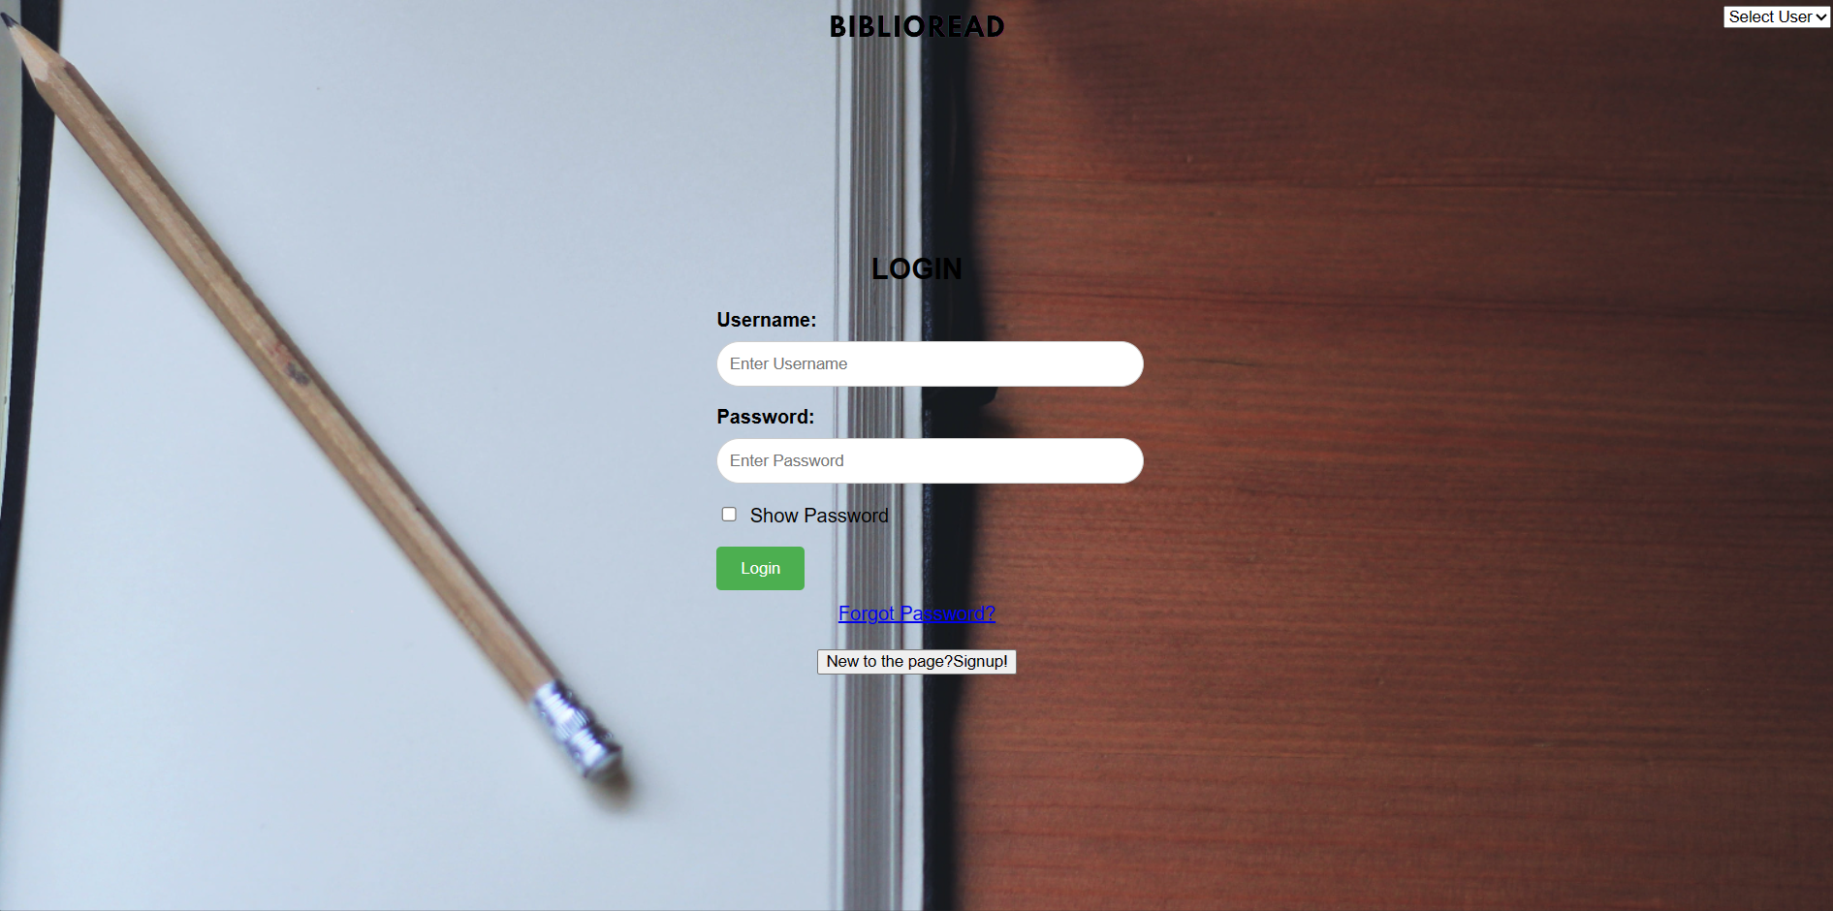

Fig 4.7.7 Screenshot of login page for user in website



Fig 4.7.8 Screenshot of login page for administrator in website



Fig 4.7.9 Screenshot of login page for publisher in website

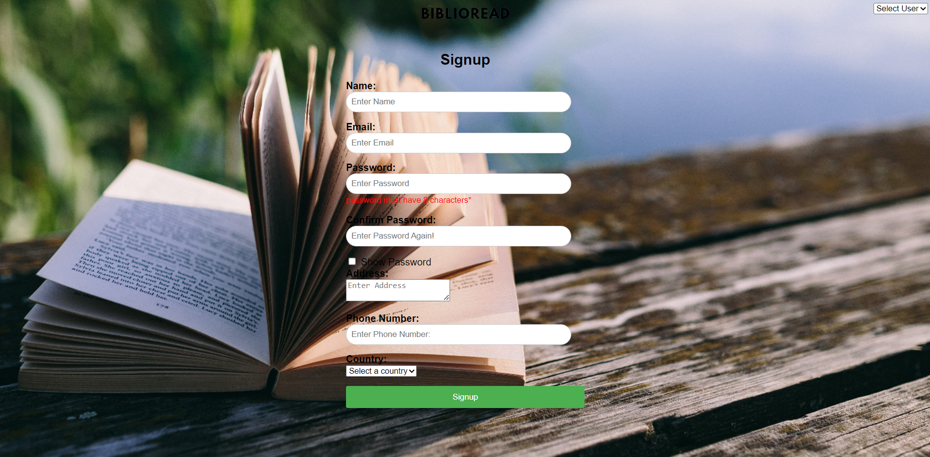

Fig 4.7.10 Screenshot of signup for user in website

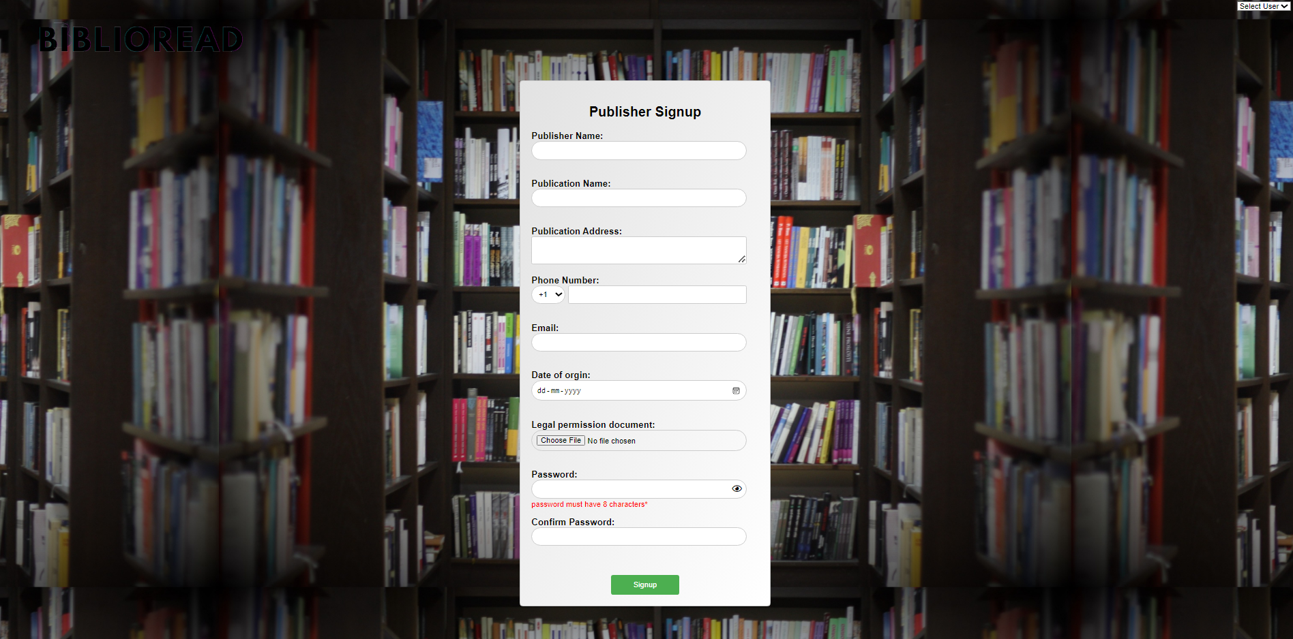

Fig 4.7.11 Screenshot of publisher signup in website

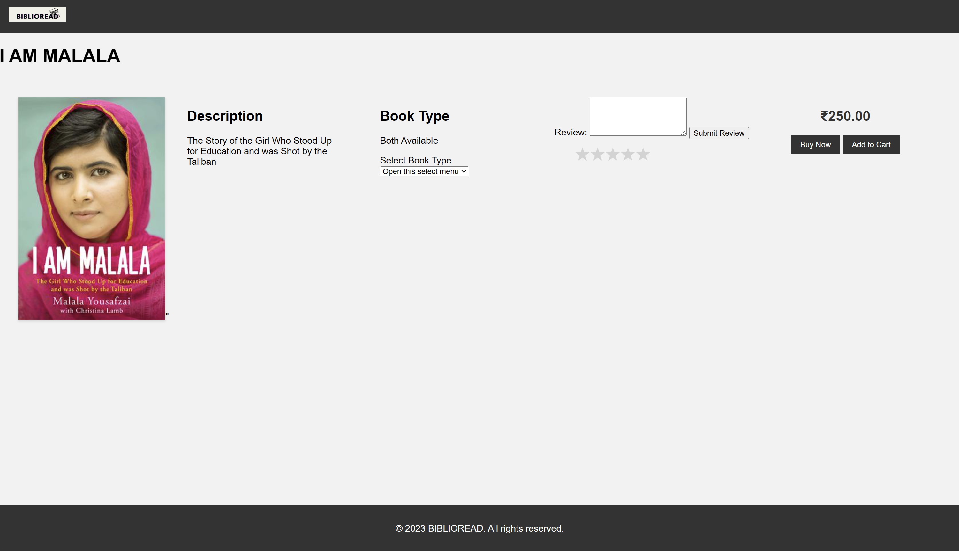

Fig 4.7.12 Screenshot of detail page of a book

# CODING

## INTRODUCTION

The coding phase in the software engineering paradigm is usually defined after the designing phase. In this phase, the developers or the coders have to implement the software design practically using any computer language(s) so that the software can be created and the user can use it. Now, coding is not just a matter of implementing the code in any suitable language as per the developer's choice. Some norms and standards are set for this purpose which is known as the coding standards.

In this project we have used GoLang as the programming language for the CLI application while HTML, PHP and JS have been used for the website. We Have adhered to the coding standards and ensured that good programming practices have been followed and there is a uniform appearance of the code.

## CODING SNIPPETS Code for view.py

from django.shortcuts import render from django.db import connection from django.http import HttpResponse

from django.shortcuts import HttpResponseRedirect,render_to_response,redirect # def index(request):

# return render(request,'index.html')

def login(request):

return render(request,'login.html')

def dietitian(request):

return render(request,'dietitian.html')

def healthclub(request):

return render(request,'healthclub.html')

def medical(request):

return render(request,'medical.html')

def nutrition(request):

return render(request,'nutrition.html')

def viewdieti(request):

return render(request,'viewdieti.html') def Registration(request):

return render(request,'Registration.html') def Registrationaction(request):

cursor=connection.cursor() un=request.GET['username'] c=request.GET['contact'] e=request.GET['email'] g=request.GET['gender'] p=request.GET['password'] cp=request.GET['conpass']

sql="insert into

registration(name,email,contactno,gender,password,conpass)values('%s','%s','%s','%s','%s','%s')"%(un,e

,c,g,p,cp)

cursor.execute(sql)

return render(request,'Registration.html') def medicalaction(request):

cursor=connection.cursor() a=request.GET['age'] h=request.GET['height'] w=request.GET['weight'] g=request.GET['gender'] op=request.GET['yes-no'] db=request.GET['deabetic'] bp=request.GET['bp'] mc=request.GET['medical']

sql="insert into

medical(age,height,weight,gender,operation,deabetic,bp,medicalcontinous)values('%s','%s','%s','%s','%s ','%s','%s','%s')"%(a,h,w,g,op,db,bp,mc)

cursor.execute(sql)

return render(request,'medical.html') def nutritionaction(request):

cursor=connection.cursor() n=request.GET['name'] a=request.GET['age'] d=request.GET['details'] f=request.GET['file'] e=request.GET['email'] c=request.GET['contact'] ad=request.GET['address'] p=request.GET['password']

sql="insert into

nutrition(name,age,details,file,email,contactno,address,password)values('%s','%s','%s','%s','%s','%s','%s'

,'%s')"%(n,a,d,f,e,c,ad,p) cursor.execute(sql)

return render(request,'nutrition.html') def dietitianaction(request):

cursor=connection.cursor() e=request.GET['email'] p=request.GET['password'] a=request.GET['age'] g=request.GET['gender'] n=request.GET['name']

sql="insert into

dietitian(email,password,age,gender,name)values('%s','%s','%s','%s','%s')"%(e,p,a,g,n) cursor.execute(sql)

return render(request,'dietitian.html') def healthclub(request):

return render(request,'healthclub.html') def healthclubaction(request):

cursor=connection.cursor() cn=request.GET['name'] ad=request.GET['address']

pl=request.GET['place'] ca=request.GET['category'] cno=request.GET['contact'] em=request.GET['email'] pas=request.GET['password']

sql="insert into

club(name,address,place,category,contactno,email,password)values('%s','%s','%s','%s','%s','%s','%s')"% (cn,ad,pl,ca,cno,em,pas)

cursor.execute(sql)

return render(request,'healthclub.html') def viewdiet(request):

return render(request,'viewdiet.html') def viewdietaction(request):

cursor=connection.cursor() t=request.GET['time'] d=request.GET['date'] dn=request.GET['name'] dur=request.GET['duration'] re=request.GET['reason'] c=request.GET['contact'] mr=request.GET['medical']

sql="insert into

viewdietitian(time,date,name,duration,reason,contact,medicalrecord)values('%s','%s','%s','%s','%s','%s','

%s')"%(t,d,dn,dur,re,c,mr) cursor.execute(sql)

return render(request,'viewdiet.html')

# SYSTEM TESTING

## INTRODUCTION

System testing is an important part of the software development life cycle that evaluates the system's compliance with its specified requirements. This testing process is conducted on a complete and integrated system to verify its functionality and performance. The objective of system testing is to detect any defects in the system, including any mismatches in the software and hardware components, and ensure that it meets the user's requirements. It also verifies that the system is ready for deployment and is capable of handling real-world scenarios. System testing can be performed manually or using automated testing tools and techniques to ensure the system is reliable, scalable, and secure.

## Unit Testing

Unit testing is a software testing method in which individual units or components of a software application are tested in isolation. The purpose of unit testing is to ensure that each individual unit is functioning as expected and that there are no defects or errors. This method involves writing test cases for each unit, running those test cases, and analyzing the results. Unit testing is typically automated, and it is performed by developers during the development process. By detecting and correcting defects early in the development cycle, unit testing helps to reduce the overall cost of software development and improve the quality of the final product.

## Integration Testing

Integration testing is a software testing method in which individual units or components of a software application are combined and tested as a group. The purpose of integration testing is to ensure that the different units or components of the software work together as expected and that there are no defects or errors introduced by the integration. This method involves testing the interactions between different units, verifying the data flow between them, and validating the overall behavior of the software application.

Integration testing can be performed manually or automated, and it is typically performed by developers or testers during the development cycle.

## Functional Testing

Functional testing is a software testing method in which the functionality of a software application is tested against the functional requirements or specifications. The purpose of functional testing is to ensure that the software application is performing as expected and that it meets the functional requirements of the end-users. This method involves testing the software application through various scenarios, verifying the input and output data, and analyzing the results. Functional testing can be performed manually or automated, and it is typically performed by testers during the testing phase of the software development life cycle.

## Regression Testing

Regression testing is a software testing method in which the software application is retested after a change or modification has been made to the software. The purpose of regression testing is to ensure that the change or modification has not introduced any new defects or errors into the software application. This method involves running a suite of previously executed test cases on the modified software application, verifying the results, and comparing them with the results from the previous version of the software. Regression testing can be performed manually or automated, and it is typically performed by testers during the testing phase of the software development life cycle.

## Performance Testing

Performance testing is a software testing method in which the performance of a software application is tested under different load conditions. The purpose of performance testing is to ensure that the software application can handle the expected load and that it meets the performance requirements of the end-users. This method involves simulating real-world scenarios, measuring the response time of the software application, and analyzing the results. Performance testing can be performed manually or automated, and it is typically performed by testers during the testing phase of the software development life cycle.

## Acceptance Testing

Acceptance testing is a software testing method in which the software application is tested against the acceptance criteria or requirements specified by the end-users. The purpose of acceptance testing is to ensure that the software application meets the expectations of the end-users and that it is ready for release. This method involves testing the software application through various scenarios, verifying the input and output data, and analyzing the results. Acceptance testing can be performed manually or automated, and it is typically performed by the end-users or a representative during the acceptance phase of the software development life cycle.

## WEBSITE

The following methods of testing were carried out to ensure reliability of the website

## Functional testing

Functional testing is a type of software testing that verifies the behavior of a software application against the functional requirements or specifications. The purpose of functional testing is to ensure that the software application performs all the functions as per the requirement and there are no defects or errors in the functionalities. It involves identifying the functional requirements, creating test cases, executing them, and comparing the actual results with the expected results. Functional testing can be done manually or automated, and it is usually performed by testers during the testing phase of the software development life cycle.

## Performance testing

Performance testing is a type of software testing that checks how well the software application performs under different load conditions. The purpose of performance testing is to identify the performance issues and bottlenecks in the software application, and to ensure that the application meets the performance requirements of the end-users. It involves simulating the real-world scenarios, measuring the response time of the software application, and analyzing the results. Performance testing can be done manually or

automated, and it is usually performed by testers during the testing phase of the software development life cycle.

## Security testing

Security testing is a type of software testing that checks the security of the software application. The purpose of security testing is to identify the vulnerabilities and loopholes in the software application, and to ensure that the application is secure and free from any potential threats. It involves identifying the security requirements, creating test cases, executing them, and analyzing the results. Security testing can be done manually or automated, and it is usually performed by testers during the testing phase of the software development life cycle.

## Usability testing

Usability testing is a type of software testing that evaluates the ease of use of the software application. The purpose of usability testing is to identify the issues and difficulties faced by the end-users while using the software application, and to ensure that the application is user-friendly and easy to use. It involves identifying the usability requirements, creating test cases, executing them, and analyzing the results. Usability testing can be done manually or automated, and it is usually performed by testers during the testing phase of the software development life cycle.

## Compatibility testing

Compatibility testing is a type of software testing that checks the compatibility of the software application with different hardware, software, and operating systems. The purpose of compatibility testing is to ensure that the software application works smoothly on different platforms, and to identify any compatibility issues. It involves identifying the compatibility requirements, creating test cases, executing them on different platforms, and analyzing the results. Compatibility testing can be done manually or automated, and it is usually performed by testers during the testing phase of the software development life cycle.

## Regression testing

Regression testing is a type of software testing that verifies that the changes made in the software application have not affected the existing functionalities. The purpose of regression testing is to ensure that the changes made in the software application have not introduced any new defects or errors, and to ensure that the software application is still working as expected. It involves identifying the changes made, creating test cases, executing them, and analyzing the results. Regression testing can be done manually or automated, and it is usually performed by testers during the testing phase of the software development life cycle.

## User acceptance testing

User acceptance testing is a type of software testing that checks whether the software application meets the expectations of the end-users. The purpose of user acceptance testing is to ensure that the software application is ready for release and that it meets the requirements of the end-users. It involves creating test cases based on the user requirements, executing them, and analyzing the results. User acceptance testing is usually performed by the end-users or the representatives of the end-users during the acceptance phase of the software development life cycle.

# SYSTEM IMPLEMENTATION

## INTRODUCTION

System implementation is the process of putting a software system into action or making it operational. It involves a series of activities that are necessary for deploying the system and making it ready for use by the end-users. This includes the installation and configuration of hardware and software components, database setup, and integration with other systems. The implementation process also involves testing the system to ensure it meets the requirements and specifications outlined during the design and development phases. The goal of system implementation is to ensure a smooth and seamless transition from the old system to the new one, minimizing disruption to business operations and maximizing the benefits of the new system.

## WEBSITE

Implementation is an activity that is contained throughout the development phase. It is the process of bringing a developed system into operational use and turning it over to the user. The new system and its components are to be tested in a structured and planned manner. A successful system should be delivered and users should have the confidence that the system would work efficiently and effectively. The more complex the system being implemented the more involved will be the system analysis and design effort required for implementation. Implementation is the stage of the system when the theoretical design is turned into working system. The implementation involves careful planning investigation of the current system and its constraints on implementing, design of methods to achieve the changeover, training of user over procedure and evaluation change over method. There are three types of implementation:

Maintenance corresponds to restoring something to original conditions, covering a wide range of activities including correcting codes and design errors and updating user support. Maintenance is performed most often to improve the existing software rather than to a crisis or risk failure. The system would fail if not properly maintained. The software maintenance is an important one in the software development because we have to spend more efforts for maintenance. Software maintenance is to improve the software quality according to the requirements. After a system is successfully implemented, it should be maintained in a proper manner. The need for system maintenance is to make the system adaptable to the changes in the system environment. There may be social, economical or technical changes, which affect system being implemented.

# CONCLUSION

All the requirements and specifications was followed as for as possible and few additional features were added that can make the application more user friendly and less complicated. The project was successfully completed within the time span allotted. All the modules are tested separately and put together to form the main system. Finally the system is tested with real data and it worked successfully. Thus the system has fulfilled the entire objective defined.

# FUTURE ENHANCEMENT

Any system which has been in use for a number of years gradually decays and become less effective because of change in environment to which it has to be adapted. For the time being it is possible to overcome problems by amendments and minor modifications to acknowledge the need of fundamental changes.

Nothing is perfect; in future we would like our prototype to be more perfect by including future improvements. The proposed system is very easy to handle so everyone can access.

* + - The entire process of the firm can be computerized.
    - More number of item details can be inserted into the database.
    - It can be integrated with the web for universal access.
    - Upgrading the performance .This system is now implemented at the client machine only but as a future enhancement we can modify the system in such a way to make it work on a client- server network. The system can be even more enhanced by making it an internet based system.
    - The efficiency of the developed system can be improved by modification. Today most of the services are based on web services. This system can also be connected online.

# BIBLIOGRAPHY

1. W3Schools [online]. Available at: [www.w3schools.com](http://www.w3schools.com/)
2. www.project management basics.com